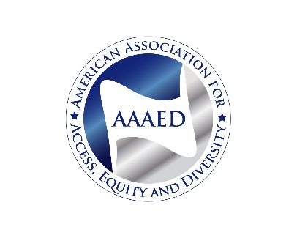
Affirmative Action Association Announces
Change of its Name

In its 40th Year the American Association for Affirmative Action Changes its Name to
The American Association for Access, Equity and Diversity

For Immediate Release: June 9, 2014
Contact: Shirley J. Wilcher
240-893-9475
execdir@affirmativeaction.org

Washington, DC, June 9, 2014- At its 40th National Conference and Annual Meeting the members of the American Association for Affirmative Action (AAAA), an organization of equal opportunity, diversity and affirmative action professionals, voted to change the name of the association to the American Association for Access, Equity and Diversity (AAAED). This decision was many years in the making and marks a milestone for the group.

Founded by affirmative action professionals in 1974, “Access, Equity and Diversity” was the slogan used by the association for many years. The name change reflects the breadth of the responsibilities that Equal Opportunity (EO) and affirmative action professionals undertake in today’s workplace. Marshall Rose, newly elected AAAED President, stated “Today’s EO professionals are responsible for Title IX compliance, equal employment opportunity investigations and diversity planning, as well as disability and affirmative action programs.” “This by no means reflects a diminution in our support for affirmative action,” he added. “We believe affirmative action is a means to achieve access, equity and diversity and we encourage institutions, corporations and governments to closely link affirmative programs with other efforts to promote diversity and inclusion in the workplace.”

A review of the job titles of association members also reflects the changes that have occurred since the 1970s. Only approximately 15 percent of members have the words “affirmative action” or “AA” in their titles, although their job functions may continue to include this activity. “Equal Opportunity” and “Diversity and Inclusion” are terms more often used today and reflect activities to serve traditionally underrepresented groups as well as those not originally contemplated in the civil rights laws.

Moreover, new professions have emerged since 1974: diversity professionals and Chief Diversity Officers (CDOs), Title IX administrators, disability specialists, and a relatively new activity in higher education: those who work to achieve “inclusive excellence.” Some groups, including members of the LBGT community, were not considered when the Civil Rights Act was enacted in 1964 or when Lyndon Johnson’s Executive Order 11246 was signed in 1965.
At its Awards Ceremony, the association honored a group that reflected the diversity and inclusion inherent in the association’s mission and that is reflected in the new name. Among the honorees were Assistant Secretary Kathleen Martinez, head of the Department of Labor’s Office of Disability Employment Policy; John D. Gonzalez, founder of JDG Associates, an EEO consulting firm; Dr. Louis Dale, Associate Vice Provost for Minority and Special Programs, University of Alabama at Birmingham; Civil Rights icon Rev. James Lawson; and Dr. Roosevelt Thomas, awarded posthumously for his leadership in Diversity Management. Texas Tech University was given the Champion of Diversity Award.

At the conference, the Association also announced the establishment of the Fund for Leadership, Equity, Access and Diversity, a 501c3 nonprofit organization. The LEAD Fund was created to promote research and education on issues related to equal opportunity, affirmative action and diversity, both domestically and internationally.

The AAAA/AAAED meeting, themed "40 Years of Affirmative Action: Envisioning the Future" was held at the Gaylord Opryland Hotel & Convention Center, 2800 Opryland Drive, Nashville, TN on June 3 - 6, 2014. For more information about the AAAA/AAAED Conference and Annual Meeting, go to www.aaaaconference.org.

AAAA/AAAED Website

888 16th Street, NW, Suite 800 * Washington, D.C. 20006 *202-349-9855 ex 1857 *
800-252-8952 * Fax: 202-355-1399 * www.affirmativeaction.org

